TOP DRIVE 1050
By

Zenon/Dial

-----------------------------------------------

Assembling the TOP-DRIVE 1050 Upgrade.

- Remove IC U10 from socket (on disk drive board)

- Where the IC U10 was located insert the TOP-DRIVE 1050 Circuit

- Connect the Blue wire )A (to TP10.
- Connect the Yellow wire )B) to Resistor R66

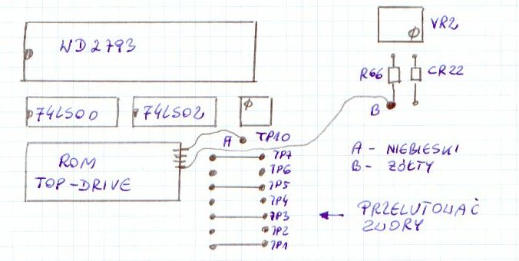
- Assemble back the Drive

- Turn ON the disc drive.

- Turn on computer. The menu of TOP-DRIVE will be reading from disc drive's ROM.

- Put disk, press Start or Select key

- If During reading, a message 'BOOT ERROR' will appear, but never mind!, that's OK.

- This TOP-DRIVE Upgrade Use EPROM 27128, because I don't have 2764. In this EPROM its two half’s have the same program.
--------------

NOTE: On board you should resolder JP1 to JP7 like on the diagram above.
If disk drive has had EPROM before, JP1 to JP7 should be ok and you shouldn't do anything with JP1 to JP7.

--------------
Module in disk drive 1050

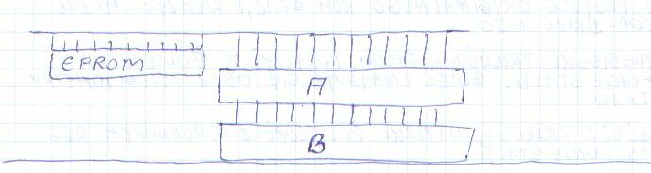

B - original socket on disk drive's board
A - additional socket. You should put this additional socket on pins of TOP-DRIVE
module and now module with additional socket put to socket B.

Description: Zenon/Dial
Translation K.P.

