BIT-WRITER INSTALLATION

We won’t get into detailed drive disassembly instructions here since they were given to you far the Super Archiver installation.

- Disassemble drive and remove shield if present.

- De-solder the BLACK wire of your SA from past TP11.

3. Remove chips 2793 at U-13and 6507 at U-9. Be careful not to break off true RED wire soldered to pin 31 of the 2793

- Bend up pin 30 of the 2793 and replace chip (notched end toward FRONT of drive) into the U-13 socket taking care not to bend any pins and make certain that all other pins are into the socket (except far pins 30, 31 and possibly pin 40 if you have a 2797)

- Add a drop of solder to bent up pin 30 of the 2793. Make certain the solder doesn't "bridge" to any other pins.

- Add a drop of solder to pin 11 of the 74LS04 which is located at U-16 (directly in FRONT of the metal canister crystal).
Pin 11 is the "middle" pin in the left row of 7 pins on the 74LS04 (positioned so the notched end of the chip is toward you).

- Taking care not to bend any pins on the bottom side of the "BIT-WRITER", solder the BLACK wire of the B-W to post
TP-11.

- Solder the RED wire of the B-W to pin 30 of 2793.

9. Solder the GREEN wire of the B-W to pin 11 of 74LS04.

Check all connections just made to be certain that no "Bridging'' hag occurred.

10. Remove foam pad from bottom of B-W and insert it into the empty 28 pin socket at U-9. Press it firmly into place by applying pressure directly aver the connector (DO NOT apply pressure at the ends of the B-W board because it may snap the board in half!).

11. Solder the BLACK wire from the SA to the 4th (empty) pad of the B-W (located next to the BLACK, RED and GREEN wires at the LEFT-FRONT of the B-W board).

12. Insert the 6507 into the empty socket of the B-W board making certain the NOTCHED end of the chip is toward the FRONT of the drive.

13. Before you totally re-assemble the drive, you may wish to just position the drive mechanism on its' four posts and power up the drive to test it. If all appears to by working, re-assemble drive.

14. Mount the dual speed pots at the rear of the drive along the top edge of the aluminum heat sink. Peel off the paper of the double stick tape and position the tiny adjustment screws of the pots so they're facing upward (for easy adjusting access). Solder the unconnected end of the wire (from speed pot circuit board) to the pin of your SUPER ARCHIVER Speed Pot that is connected to chip 2917. We're having you solder it to the Speed Pot pin rather than the chip pin because the chip is in a somewhat difficult location for soldering and to add an extra wire to the chip pin would be clumsy.

15. Now boot the new diagnostic program on your BIT-WRITER disk. Press the appropriate drive number, then select the RPM program. You'll be asked to calibrate FOUR separate speeds:

A. NORMAL. (288) - Adjust the drives original speed pot (at location VR2) to 288. Press START.
B. SLOW 1 (282) - Adjust the GREY colored pot (50k ohms) to 282. Press START.
C. SLOW 2 (275) - Adjust the BLACK pot (20k ohms) located next to the gray pot until a speed of 275 is achieved. Press START.
D. SLOW 3 (270) - Adjust the SUPER ARCHIVER pot (20k ohms) to 270. Press START to return to 288.
E. Press RETURN to return to main menu.

NOTE! We are using an overly accurate speed calibration program. It is normal for the speeds to fluctuate by one or two Rpm’s. Try to make your adjustments so they AVERAGE the suggested speeds of 288, 282, 275, and 270. Also, a reading of 300+ may momentarily flash on the screen. As long as the majority of the readings are within the desired range, ignore the brief 300+ values.

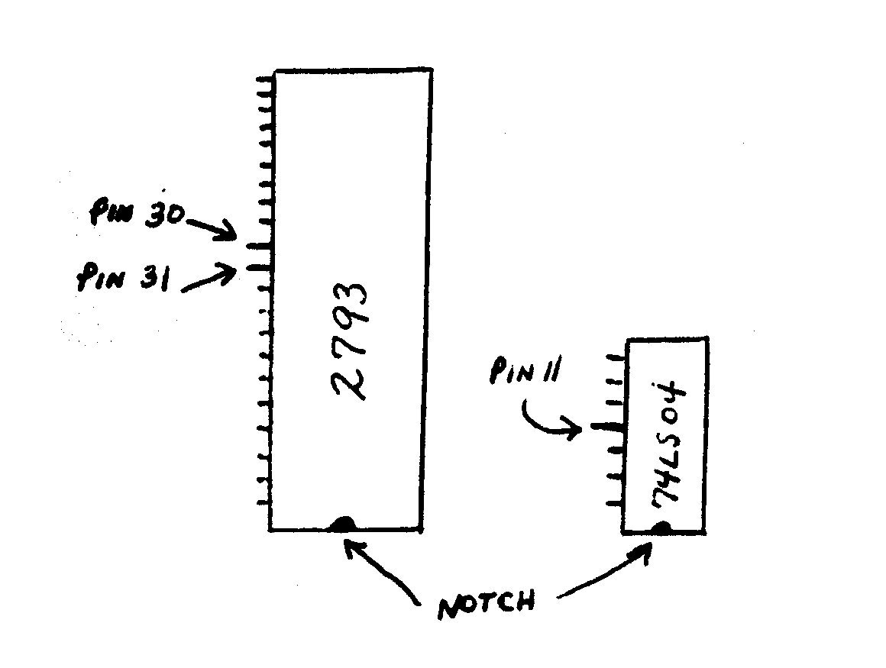
NOTE! NOTE! We have found that a few ATARI drives are using really POOR QUALITY sockets at locations U-10 and U-9. The way to identify these crummy sockets is if the SUPER ARCHIVER and/or the BIT-WRITER seem to always want to "pop-out" of their respective sockets instead of staying firmly seated in place. If you suspect your drive has the POOR QUALITY sockets, replace them with Radio Shacks' "low profile" sockets (approximately $0.69 each). If you can't install them yourself, send your drive to COMPUTER SOFTWARE SERVICES and we'll install-them at NO CHARGE.

BIT-WRITER Operational Instructions

Understand that the B-W has been designed and calibrated to accurately reproduce LONG FULL SECTOR TRACKS (like 34 sectors/track). While it was not designed to copy normal 18 sector/track formats, it WILL copy them MOST of the time if the Write-Splice feature is implemented. The B-W was designed to work with and compliment The Super Archiver and should be used only when The Super Archiver cannot reproduce a particular track of data properly (e.g. if the internal "clocks" of your disk drive are not calibrated properly, the SA may not be able to read or write a difficult sequence of sectors. The Bit-Writer doesn't write sectors, it writes a complete track of BIT'S so it shouldn't have a "logic" or timing problem even if your drives' clocks are marginal.)

A brief word about "Write-Splicing": Without getting overly technical, Write-Splicing occurs within the floppy controller to
Correct synchronization errors during the writing process of individual sectors. Because the Bit-Writer READS individual SECTORS but WRITES complete TRACKS of data, an error can occur if the end of the track overwrites the beginning of the track. Write-Splicing tries to correct this error. Once a track has been written with The Bit-Writer, Write-Splicing is not required an subsequent generation copies.

A description of The Bit-Writer menu functions are as follows:

Enter Source and Destination drive numbers when prompted. Remember, Bit-Writer MUST be present in BOTH the source and destination drive.

A. COPY DISK - This will attempt to copy every track on the disk. If this is a first generation copy, Write-Splice should definitely be ON. Be reminded you should use The Super Archiver to copy as many tracks as possible. Using The Bit-Writer to copy EVERY track on a disk will result in a 50/50 chance of a successful copy.

X. SELECTED TRACK COPY - You may select any specific track (in decimal) or press "X" to program the reading of specific tracks. If "X" is selected, you must answer "Y" or "N" for each track you wish to read or skip. After you've programmed the tracks you wish to read, press "X" and the program will begin to read your SOURCE disk. You'll notice data displayed under each track number. For most users, this data can be ignored. It was designed to help US understand a particular tracks' parameters should you not be able to successfully copy it.

R. RE-COPY TRACKS - This feature allows you to re-copy the same tracks without having to re-program your choices.

S. COPY LARGE TRACKS - This feature will allow you to SCAN for a pre-defined number of large tracks. The normal default is set for 21 SECTORS/TRACK..

P. CHANGE SOURCE/DESTINATION DRIVE - If you have more than one Bit-Writer, this will allow you to re-configure your drives without losing any-pre-defined track settings you may have already programmed.

As you can see, this is a fairly simple program to master. Keep

mind that its' primary use is to copy the long un-copyable tracks of Electronic Arts (track 2 only) and The Synfile, Syncalc series along with future protection schemes.

Enjoy,

COMPUTER SOFTWARE SERVICES
P.0. Box 17660
Rochester, NY. 14617
(716) 467-9326

