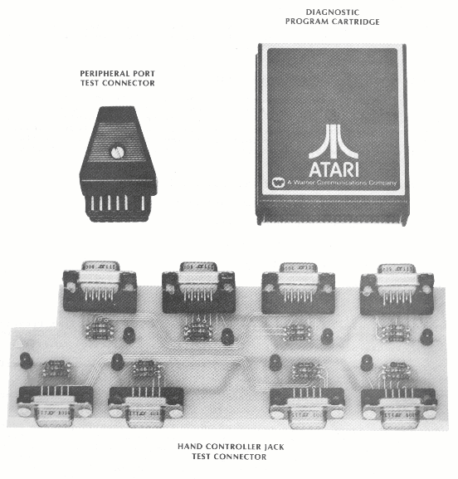
Figure 5-2. Stand Alone Test Special Tools

5-8 System Service Manual

- D = Display Options
P = Pass/Fail
E = Display Error Table
S = S ing1Q Run of Test
C = Continuous Run of Test

- A = Any Video Test

- G = Graybar Test

- C = Colorbar Test

- R = RAM Test (Tests Up to 32K)

- P = Port Test (Used in Conjunction with Port Jumpers)

- T = Tone Test (4 Registers - 8 Tones each)
Proceed with each of the following tests, noting any errors that occur.

Display Option

The test procedures and results can be varied by entering Display Option commands. To enter the commands you must first type 'D' and carriage return (or spacebar) to enter the D isplay Option Mode. Once in the Display Option Mode the screen will prompt you to enter the test format, either a PASS/FAIL indication or an E RROR TABLE display.

Enter:
P = PASS/FAIL Indication
E = ERROR TABLE Display
Next the scree~n will prompt you to enter the test moder either SINGLE TEST or CONTINUOUS TESTING.
Enter:
S = SINGLE TEST
C = CONTINUOUS TESTING

These special options are only used with the RAM Memory and Port Tests.

VIDEO TESTS
The video test consists of a series of three tests designed to check video display, color adjustment, and screen luminosity.
A = ANY VIDEO TEST

ATARI Personal Computers 5-9
- Enter Command Letter 'A', carriage return (or spacebar).
- Refer to Figure 5-3, for correct screen display.
- Check the V’s in the upper right of the screen to be sure they are not inverted.
- Observe if any of the vertical bars are missing or appear in a different sequence than Figure 5-3
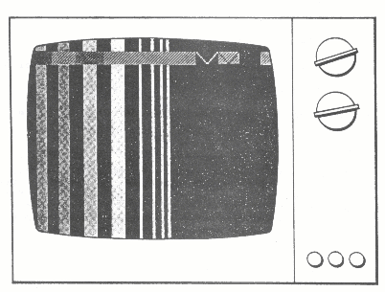

Figure 5-3. Any Video Test Screen Display

G = GRAYBAR TEST

1. Enter Command Letter 'G', carriage return (or spacebar).
- Refer to Figure 5-4 for screen display appropriate to this test.
- Screen is divided into eight equal horizontal bars.
- The shading begins with the horizontal bar at the top of the screen being black and increments gradually to the bottom horizontal bar being white. The top four horizontal bars can be noticeably different in color shade than the bottom four horizontal bars.

5-10 System Service Manual
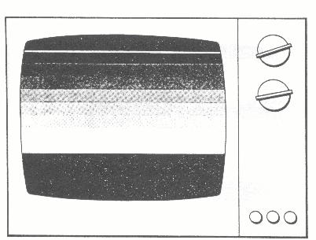

Figure 5-4. Graybar Test Screen Display

COLORBAR TEST
1. Enter Command Letter ‘C’, carriage return (or spacebar)

2. Refer to Figure 5-5 for the correct screen display for the Color Bar Test.
- Between the top gray bar on the screen and the reference gray bar near the bottom of the screen are fifteen color bars developińg a rainbow effect.
- The color bars directly above and below the gray reference bar should be identicalr both bars green tint.

3. If the color bars directly above and below the reference bar are n ot identical proceed with the C olor Bar Adjustment procedures that follow. If the color bars are identical then the Video Test is Complete and proceed to the RAM TEST.

Colorbar Adjustment Procedure

1. The 400 Console should remain powered-up and the Color Bar Test entered.
2. The 800 Console must be powered down and the Cartridge Door assembly removed, proceed as follows:

ATARI Personal Computers 5-11
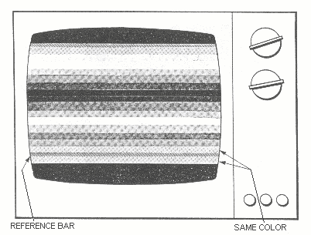

Figure 5-5. Color Bar Test Screen Display

- Set System Power ON/OFF switch to OFF.

- Open Cartridge Door

- Rotate Cartridge door clamps to the outside

- Raise Cartridge Door assembly 1/4 inch, then pull towards you and lift off

- Use small flat-blade screwdriver to depress Interlock switch

- Set System Power ON/OFF switch to ON

- Initialize Color Bar test to display screen format
3. Turn the Console 180 degrees to provide access to the back of the Console.
4. Refer to Figure 5-6 for the 400 ConsoleT and to Figure 5-7 for the 800 Console when performing the following steps.
- Insert a small (No. 1) flat-blade screwdriver or an electronic adjustment tool into the plastic grating of the 400 Console, or into the access hole of the 800 Consolet until it conta~ts the variable resistor.

5-12 System ServiCe Manual
- Adjust the variable resister until the two color bars are identical.

5. Once adjusted, reassemble the 800 Console and proceed to the RAM Test. If unable to adjust the color bars refer to paragraph 5.4, Troubleshooting.
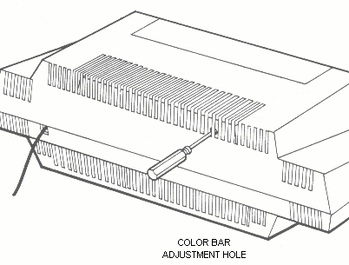

Figure 5-6. 400 Console Color Adjustment

RAM TEST

The RAM Test utilizes six different tests to verify the operation of the RAM Memory boards. The RAM Test checks the RAM memory in 8K blocks. The number of 8K blocks is entered as part of the command sequence. If you enter a number indicating less memory than actually installed the diagnostic program will only check the memory indicated. A maximum of 32K of RAM memory can be checked. In order to check additional memory it will be necessary to swap tested memory with untested memory.

Before running the RAM Test it is necessary to determine the type of display format and mode for the test. Default setting for the display format is a PASS/FAIL indication. Default setting for the test mode is a single test. RAM Memory boards should pass three complete series of diagnostic tests before acceptance. Typically a RAM Test is run as follows :

ATARI Personal Computers 5-13

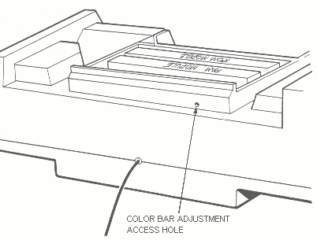
Figure 5-7. 800 Console Color Adjustment

1. Enter Command Letter 'D', carriage return (or spacebar), to Display Options.
- Enter Command Letter 'E', carriage return (or spacebar), to display Error Table.

3. Enter Command Letter 'C', carriage return (or spacebar), to enable continuous testing.

4. Enter Command Letter 'C', carriage return (or spacebar), to select RAM Test.

5. Enter number of 8K memory blocks; 1 = 8K, 2 = 16K, 3 = 24K, 4 = 32K, carriage return (or spacebar).

In approximately ten seconds a matrix similiar to Figure 5-8 will be displayed on the screen. In the lower four video lines on the screen, outlined in reverse video, will appear the prompt RAM TEST, indicating one complete test sequence. To continue testing, do nothing. To stop the test, hit carriage return (or spacebar) and the testing will stop at the completion of the present test.

Observe rows D and E for '1' indicatorr signifying a RAM failure. Also observe if the failure indication occurs in the same column each test or if it moves about. If a failure does occur record the failing loeation and rerun the RAM Test in its entirety making sure that the

5-14 System Service Manual

RAM 8K memory block size was correctly specified. If the failure still exists refer to paragraph 5.4, Troubleshooting.
Repeat the RAM Test for each of the 8K or 16K RAM memory boards or modules, in excess of 32K.
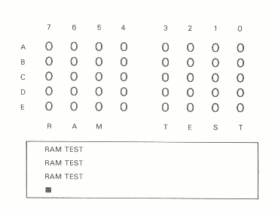

Figure 5-8. RAM Test Matrix Screen Display

PORT TEST
This is a test of the ability of the 400/800 Computer Consoles to communicate with the outside world through the Hand Controller ports and the Peripheral port.

Check to see that the Peripheral Port Jumper Assembly and the Controller Port Jumper Assembly are securely inserted in their respective ports.
Before running the PORT Test it is necessary to determine the type of display format and test mode desired. Default setting for the display format is a PASS/FAIL indication. Default setting for the test mode is a single test. (If the Display Options have already been changed from the default settings, ie., RAM Test, they need not be reestablished). Typically a PORT Test proceeds as follows:

1. Enter Command Letter 'D', carriage return (or spacebar), to

ATARI Personal Computers 5-15
Display Options.

2. Enter Command Letter 'E', carriage return (or spacebar), to display Error Table on screen.

- Enter C ommand Letter 'C', carriage return (or spacebar), to initiate continuous testing.

- Enter Cornmand Letter 'P', carriage return (or spacebar), to initiate PORT Test.

Almost immediately a matrix similiar to Figure 5-9 will be displayed on the screen. In the lower four video lines on the screenr outlined in reverse video, will appear the prompt PORT TEST, indicating one complete test sequence. To continue testingr do nothing. To stop the test, hit carriage retnrn (or spacebar) and the testing will stop at the completion of the present test.

The Error Table displayed should be all zeroes, if a one (1) a ppears in any portion of the matrix an error condition exists. Record the error location and refer to paragraph 5.4, Troubleshooting.

NOTE

A blinking one (1) in position A-5 of the Error Table may not signify an error condition. A software error exists in the Stand Alone Test Program. The signal in question is the motor control line and will be more thoroughly tested in the Program Cassette Recorder Test.

TONE TEST

The TONE Test checks the sound generation Circuits of the Consoles and each of the four sound registers for tone and volume control. The volume on the television set should be set in the middle of the range for this test. The TONE Test must be run in its entirety for each of the four sound registers.

Proceed as follows:

1. Enter Command Letter 'T', carriage return (or spacebar), to initiate TONE Test.
2. Enter sound register number (1 to 4) to be tested when prompted by the screen display.

Eight tones are generated in succession, starting with the highest pitch down to the lowest. The first three tones are very high frequencies and may be inaudible to some people. Each tone starts at maximum volume and 'fades' to minimum volume.

The complete TONE Test, steps 1 and 2, should be run for each of the
our sound registers.

5-16 System Service Manual
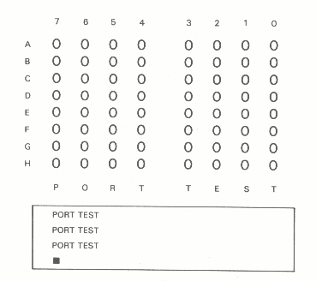

Figure 5-9. PORT Test Error Table Screen Display

5.4 TROUBLESHOOTING GUIDE

The following table provides a list of possible failures at different points in the power-up sequence and preceeding test procedures. The table will list the failure, probable cause and the appropriate test procedure to isolate the problem to a printed circuit board or integrated circuit.

ATARI Personal Computers 5-17

Table 5-1. Troubleshooting Guide

Description | Possible failure | Test Procedure
MEMO PAD TEST  - Green Screen ; Loose or Dirty ; 1 ;  - Black Screen ; C ontacts with ; ;  - Random Characters on Screen ; RAM or CPU Board ; ;  - Unit Locks Up  - Character begin scrolling across screen | Loose or dirty contacts with RAM or CPU boards  Motherboard | 1  2
VISUAL INSPECTION  - Damaged or bent pins  - Cover Closed switch will not work properly  - RF Cable cut or badly damaged  - Bare or pinched area on RF cable | Replace damaged board  Plunger or Power Supply  Replace RF Cable  Replace RF Cable | 2  2  Replace immediately  Replace immediately
KEYBOARD TEST  - Key depressed not displayed  - Key depressed not same key that appeaes on screen  - Characters begin scrolling across screen | Motherboard  Or  Keyboard | 2
STAND ALONE TEST  - System Error (can not power-up with Stand Alone Test Cartridge inserted)  - Fails Any Video Test  - Fails Color Bar test  - Fails Gray Bar test  - Fails Port test  - Fails RAM Test  - Fails Tone Test | Cartridge Guide  RAM Memory Board  CPU Board  Motherboard  RAM Memory Board  Motherboard | 2  2  2  2  2
PICTURE QUALITY TEST  - Herringbone screen  - Snowy picture or no picture  - Blurred picture  - White Dot Pattern on screen (usually vertical pattern)  - Picture upside-down when running programmed software. (Program Cartridge) | Power Supply  RF Cable  Power Supply  RAM Memory Board  CPU Board | 3  3  3  3  3
- Power LED not ON and no picture | Power Supply | 2
- Screen oscillation wgen using Paddle Controller | Motherboard needs Engineer fix | 2
- Will not perform math calculations | CPU Board | 2

5.4.1 Troubleshooting -- Procadure Number One

This troubleshooting procedure is intended to be followed when the Console System fails to power-up correctly. Symptoms include Green Screen, Black Screen, Random Characters on Screen, or Unit Lock-Up.
This procedure assumes that the System Power ON LED is lit and the screen exhibits some symptom of Console control. If these two conditions do not exist proceed to Troubleshooting - Procedure Number Two.

ATARI Personal Computer 5-19
Proceed with the following steps to troubleshoot the system:
1. Disassemble the Console using the instructions outlined in paragraph 5.5 for the 400 Console, and paragraph 5.6 for the 800 Console.

2. Clean the RAM Memory PCB and CPU PCB contact fingers per the instructions outlined in paragraph 5.2.1, PCB Contact Cleaning and Lubrication.

- Assemble the individual boards to operate the system out of the casting, see Figures 5-10 and 5-11. Refer to paragraphs 5.7 and 5.8 for assembly instructions. Plug low voltage power adapter into the System Power jack.

4. Perform System Check-Out, refer to paragraph 5.3.

NOTE

Television screen interference is normal when the system is operated without the aluminum casting.

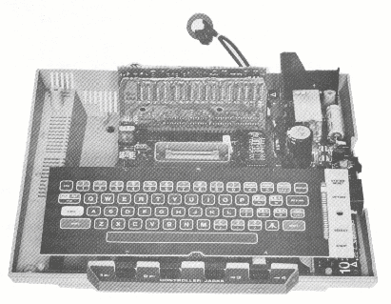
- If the system will not power-up properly, proceed to Troubleshooting Procedure Number Two.

Figure 5-10. 400 Console, Assembled Without Casting

5-20 System Service Manual
5.4.2 Troubleshooting - Procedure Number Two

This procedure in conjunction with Table 5-1, Troubleshooting Guide, is used to isolate the failure to a specific printed circuit board. Table 5-1, provides the most probable failing PCB for the described problem. This procedure will help isolate the failing PCB if the suggested faulty PCB is not the problem.

Proceed with the following steps to isolate the faulty PCB:
1. Disassemble the Console using the instructions outlined in ATARI Personal Computers 5-21,paragraph 5.5 for the 400 Consoler and paragraph 5.6 for the 800 Console.

2. Clean the RAM Memory PCB and CPU PCB contact fingers per the instructions outlined in paragraph 5.2.1, PCB Contact Cleaning and Lubrication.

3. Assemble the individual boards to operate the system out of the casting, see Figures 5-10 and 5-11. Refer to paragraphs 5.7 and 5.8 for assembly instructions. Plug low voltage power adapter into the System Power jack.

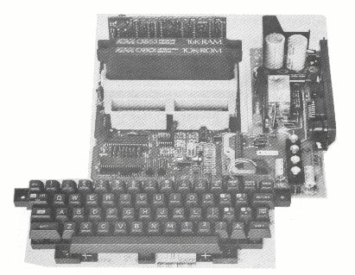
4. Perform System Check-Out, refer to paragraph 5.3. Continue from this point if the system fails System Check- Out.

Figure 5-11. 800 Console, Assembled Without Casting

ATARI Personal Computers 5-21
The following is a list of guidelines to aid in the troubleshooting of faulty printed circuit boards:

- Use only known good spares for substitution.

- After each printed circuit board is suhstitutedr retest system to determine if the problem has been Corrected.

- Leave the substituted printed eir~użt board in the system until the defective part is identified.

- Ensure that the System Power is OFF before substituting printed circuit boards.

- Place defective part back into system and recheck to verify failure detection

5. Replace the printed circuit board listed in the Possible Failure column of Table 5-1, and run System Check-Out to determine if the p roblem still exists.

If the problem is corrected by replacing the suggested printed circuit b oard refer to paragraph 5.4.4, Integrated Circuit Replacement Procedures. If the problem has not been eliminated, leave the substituted board in the system, identify the removed board for future replacement, and proceed to step 6.

6. Use the following replacement sequence to 'shot-gun' the problem if the suggested failing printed ci.rcuit board did not eliminate the problem.

- Power Supply Printed Circuit Board

- CPU Printed Circuit Board

- RAM Memory Board

- ROM Operating System Board (800 System only)

- Motherboard

- Keyboard

If the problem is corrected by replacing the suggested printed circuit b oard refer to paragraph 5.4.4, Integrated Circuit Replacement Procedures. If the problem has not been eliminated, leave the substituted board in the system, identify the removed board for future replacement, and proceed to the next suggested replacement board.

5-22 System Service Manual
5.4.3 Troubleshooting - Procedure Number Three

This paragraph describes the procedures required to correct ‘poor’picture quality. Poor picture quality is usually a result of a damaged RF Cable, defective power supply or motherboard. If the Aluminium Casting has been removed it is necessary test, refer to paragraphs 5.7 and 5.8 for the correct replacement procedures.

REPLACE RF CABLE

- Remove top cover per Disassembly instructions, refer to paragraphs 5.5 and 5.6.

- Unplug the RF Cable from the Power Supply jack and the TV Switch Box.

3. Plug spare RF Cable in Power Supply jack and the TV Switch Box.

4. Perform System Check-Out procedure, paragraph 5.3, to determine if problem has been corrected.

If replacing the RF Cable has corrected the problem, install the new RF Cable according to the instructions outlined in paragraphs 5.7 and 5.8. If the RF Cable was not the problem, leave the substituted RF Cable in the system, tag the existing RF Cable for future replacement, and proceed to Power Supply Replacement.

POWER SUPPLY REPLACEMENT

1. Remove Power Supply from the system using procedures outlined in paragraphs 5.5 and 5.6. If it was necessary to remove the Keyboard during the removal of the Power Supply reinstall the Keyboard before replacing the Power Supply.

2. Install new Power Supply in the system using procedures outlined in paragraphs 5.7 and 5.8.

3. Run the System Check-Out procedures to determine if the problem still exists: refer to paragraph 5.3.

4. If the problem has been eliminated, lave the substituted Power Supply in the system, reconnect the original RF Cable and run the System Check-Out procadures again to determine if the problem has been entirely corrected.

If replacing the Power Supply did not correct the 'poor' picture quality problem, refer to Troubleshooting - Procedure Number Two.

5.4.4 Integrated Circuit Replacement Procedures

The results recorded during the System Check-Out procedures can pin-point a failing integrated circuit on a printed circuit board. Indications from the System Check-Out can point to failing integrated circuits on three

ATARI Personal Computers 5-23
separate printed circuit boards, the motherboard, the CPU PCB, and the RAM Memory PCB. Previous Troubleshooting paragraphs, Procedures One, Two, and Three have already isolated a failing printed circuit board. The following paragraphs will provide additional information to isolate the failing integrated circuit (Chips).

RAM MEMORY BOARD

The test results and chip replacement procedures are the same for either the 8K or 16K RAM Memory boards. Chip replacement for both the 8K board and 16K board will be the same, all boards will be repaired with 16K chips.

This procedure assumes that the RAM Memory board has already been cleaned and lubricated according to the procedures outlined in paragraph 5.2.1. If this has not been doner do so at this time, and rerun the System Check-Out to verify a failing RAM Memory board.

Before beginning to replace chips, check both 74LS158 chips (Z503 and Z504) to ensure that they are identical, refer to Figures 5-12 and 5-13 for reference:
- Same Date Codes
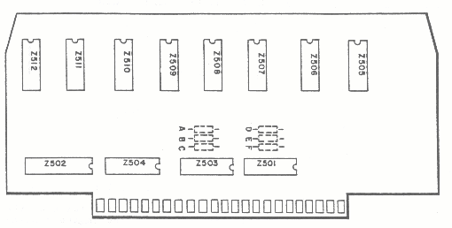
- Same Manufacturer

Figure 5-12. RAM Memory Board Locations, 8K
Review the notes you made during the RAM TEST, rows D and E of the test indicate which RAM chip was failing during the test, for example:

ATARI Personal Computers 5-25

Memory Bits 7 6 5 4 3 2 1 0
Row D 1 0 0 0 0 0 0 0
Row E 0 0 0 0 0 0 0 0
Replace Chip Z506 Z505 Z507 Z509 Z508 Z510 Z511 Z512

The above example would indicate that chip Z505 is failing the RAM Test and should be replaced. Before replacing any chips on the RAM Memory board the following troubleshooting hints should be read.
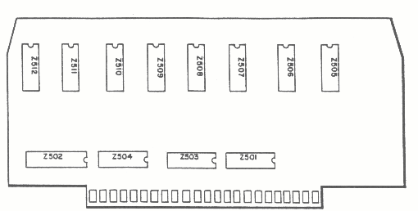
- When a failed RAM Memory board exhibits constantly changing failures the demultiplexing chips (Z503-Z504) are probably defective. Both chips must be the same manufacturer and the same date.
Figure 5-13. RAM Memory Board Locations, 16K
- When a failed RAM Memory board exhibits a 'Solid' failure (the failure does not change when the unit is tested in the continuous mode), probably that particular RAM chip is defective. (Second choice, the Data Buffer chipr Z502).
- If the test fails at address hexadecimal 4000 (Rows B and C: 0100 0000 0000 0000) a nd the data read back is hexidecimal 40 (Rows D and E: 0100 0000), the same as the high order address byte, the board under test is probably never being enabled. The Board Select chip, Z501, could be defective.
- If the RAM Memory board being tested crashes the system (Green Screen) probably the Data Buffer chipr Z502, is defective. Second choice, Board Select chip, Z501, as this also handles the refresh signal.
- Use only known good chips and leave substituted chips in the printed circuit board until the failing chip is identified.
5-26 System Service Manual
- Test printed circuit board in system after each chip is replaced to determine if failure continues.
- Before a chip is changed or a board is added or removed to/from the system, power the system down.

CPU Printed Circuit Board

The CPU printed circuit board contains seven chips that provide the 'brains' of the system, see Figure 5-14. Each of the chips is explained brieflyr to enable selecting the correct chip to replace. If the selection of a chip does not correct the problem, then replace the chips in the order that they are presented.
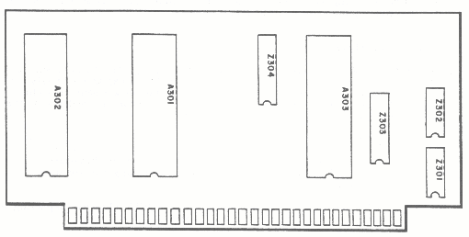

Figure 5-14. CPU Printed Circuit Board, Locations

- A303 - This is the 6502B Microprocessing Unit.
- A301 - This is the CTIA chip, which is used to generate all video and sync signals for the television screen.
The PORT Test indicates a defective CTIA chip by displaying a '1' in
Row F, any position.
- A302 - This is the ANTIC chip, which is used for both control of the CTIA and refresh operations on the dynamic RAM memory.
- Z303, Z304 - These are 74LS244 chips used as one direction tri-state buffer for MPU address lines.
- Z302 - This is a 7474 chip used to generate phase 1 and 2 clocks as well as processing HALT commands.
- Z301 - This is a 74LS02 chip used to help in the generation of the phase 1 and 2 clocks, helps with the processing of HALT commands and Read/Write signals.
- Use only known good chips and leave substituted chips in the printed circuit board until the failing chip is identified.
- Test printed circuit board in system after each chip is replaced to determine if failure continues.

ATARI Personal Computers 5-27

- Before a chip is changed or a board is added to or removed from the system, power the system down.

5.4.5 Motherboards

The 400 and 800 Motherboards contains several integrated circuits with many diverse functions. Each of the integrated circuits is explained briefly, to let you choose the correct chip to replace. If the replacement of a chip does not correct the problem, then replace the chips in the order that they are presented. Refer to Figures 5-15 and 5-16.

400 Motherboard

- A101 - Used to control POT lines, audio signal, keyboard information lines as well as printer and floppy control lines (POKEY chip).
The PORT Test indicates a defective POKEY chip by displaying a '1' in Rows G, H, I, or J in any position.

- A102 - Used to control joystick lines, and Program Cassette Recorder control lines (PIA chip).The PORT Test indicates a PIA chip by displaying a '1' in Rows A, B, C, D, or E in any position.

- Z102 - Used to receive data from POKEY chip, translate the information and send it to the keyboard.

- Z101 - Used to receive data from the keyboard, translate the information, and send it to the POKEY chip.

- Z104 - Used to decode RASTIME and R/'4V Late signals.A111 - Used as buffers for video and lum lines. Also part of the Power ON Reset Circuit.

- Z103, Z015 - Used to decode Memory Map for computer.

- A103, A104, A105 - Used to hold Operating System and some BASIC Language programs.Use only known good chips and leave substituted chips in the printed circuit board until the failing chip is identified.

- Test printed circuit board in system after each chip is replaced to determine if failure continues.

- Before a chip is changed or a board is added or removed to/from the system, power the system down.

5-28 System Service Manual
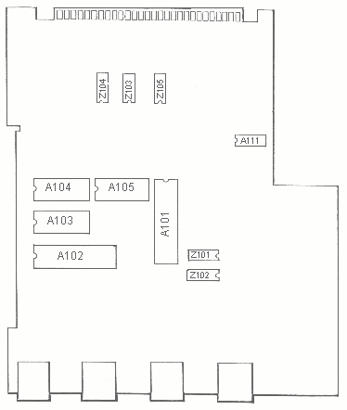

Figure 5-15. 400 Console Motherbqard~ Locations

ATARI Personal Computers 5-29
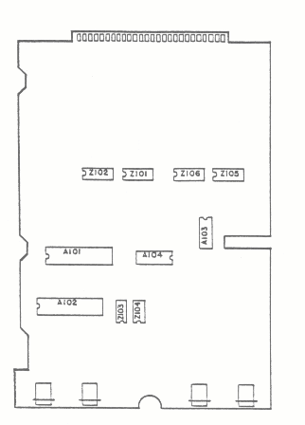

Figure 5-16. 800 Console Motherboard, Locations

800 Motherboard

- A101 POKEY chip - Used to control POT lines, audio signal, keyboard information lines as well as printer and floppy control lines.
The PORT Test indicates a defective POKEY chip by displaying '1' in Rows G, H in any position.

- A102 PIA chip - Used to control joystick lines, and Program Cassette Recorder control Lines.
The PORT Test indicates a PIA chip by displaying a ' 1' in Rows, A, B, C, D, or E in any position.

5-30 System Service Manual
- Z103 - Used to receive data from POKEY chip, translate the information, send data to keyboard (Outputs from POKEY).

- Z104 - Receive data from keyboard, translate data, send data to POKEY chip (Inputs to POKEY).

- Z102 - Used to develop READ/WRITE early and late signals. Used to decode MEMORY MAP for computer.

- A103, A104 - Buffer for video and lum lines - Part of POWER-RESET circuit.

- Z101 - Develop MEMORY MAP for computer.Z105, Z106 - Bi-directional buffers for data lines.

5.5 DISASSEMBLY, 400 COMPUTER CONSOLE
This paragraph describes the procedures required to disassemble the 400 Computer Console. Proceed after reading the following notes.
1. Be very careful about mixing screws. The Plastic and aluminum parts will easily strip if the wrong size screw is used.
2. Excessive torque on screws will strip the plastic and aluminum parts:
- Plastic - 6 inch pounds torque maximum.
- Aluminum - 10 inch pounds torque maximum.

3. Protect the plastic surfaces of the console by working on a soft surface when the console is turned over, bottom up.
4. Use all static control precautions when handling any printed circuit board.

Access to Keyboard and Power Supply:
- Top cover removal, refer to Figures 5-17 and 5-18
- Set unit on its back
- Remove 4 screws (no. 6 20x1/2) from bottom cover
- Set unit upright
- Unhook Top Cover from Keyboard
- Open Cartridge Door o Lift Top Cover off

ATARI Personal Computers 5-31
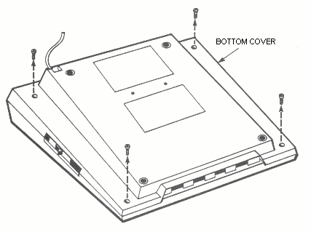

Figure 5-17. 400 Console, Bottom Cover Screw Location

2. Keyboard removal, refer to Figure 5-19
- Remove single Keyboard screw (no. 6 32x1/4)
- Raise left end of Keyboard and disconnect Keyboard Ribbon Cable

3. Power Supply Removal, refer to Figure 5-20 o Disconnect RF Cable from Power Supply
- Remove two screws (no. 6 32x3/8) from Power Supply
- Gently pull Power Supply away from casting 1/4 inch and lift out the I nterlock Switch plunger
- Lift Power Supply straight up off the Motherboard connector p ins.

Access to CPU, RAM, and Motherboard:
1. Module Assembly removal, refer to Figure 5-21
- Disconneet and remove Speaker assembly
- Lift Module Assembly out of Bottom Cover

2. CPU and RAM Printed Circuit Board Removal

5-32 System Service Manual
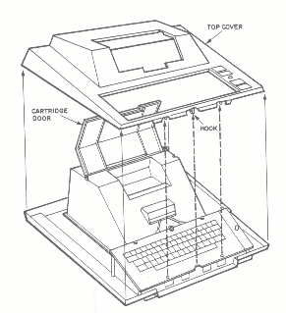

Figure 5-18. 400 Console, Top Cover Removal

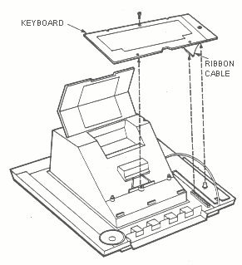

Figure 5-19. 400 Console, Keyboard Removal

ATARI Personal Computers 5-33
- Close and latch Cartridge Door
- Set Module Assembly on its back
- Remove eight screws (no. 6 32x3/8) from Bottom Shield and lift off

4. Lift Motherboard assembly out of Aluminum Casting

- Gently unplug CPU and/or RAM Memory board

- Unhook and remove plastic Cartridge Guide

5.6 DISASSEMBLY, 800 Computer Console

This paragraph describes the procedures required to disassemble the 800 Computer Console. Proceed after reading the following notes.

COMPUTER CONSOLE
- Be careful about mixing screws. The plastic and aluminum parts if the wrong size screw is used.
- Excessive torque on screws will strip the plastic and aluminum parts.

- Plastic - 6 i.nch pounds torque maximum
- Aluminum - 10 inch pounds torque maximum
3. Protect the plastic surfaces Qf the console by working on a soft surface when the console is turned over on its back.

4. Use all static control precautions whan handling any printed circuit board.

Access to RAM Memory boards and ROM Memory board
- Cartridge Door assembly removal, refer to Figure 5-22
- Set System Power switch to OFF.
- Open Cartridge Door
- Rotate Cartridge Door clamps to the outside
- Raise Cartridge Door assembly 1/4 inch, then pull towards you and lift off

5-34 System Service Manual
2. RAM Memory Module and ROM Memory Module removal

Lift out RAM Memory Modules
Lift out ROM Memory Modules

Access to Power Supply and Keyboard Assembly
1. Bottom Cover removalr refer to Figure 5-23 o Se t sys tem on its back
- Remove the five screws (no. 6 32x3/8) from Bottom Cover

- Tilt back-end of Bottom Cover up and toward you to remove

2. Printed Circuit Board Removal, refer to Figure 5-25

3. Keyboard removal, refer to Figure 5-24
- Remove four screws (no. 6 32x5/8) from four corners of Keyboard

- Lift Keyboard out of Top Cover

NOTE

Use all static protection precautions when handling printed circuit boards.
- Remove two screws (nq. 6 32x3/8) from aluminum casting flange.
- Remove single screw (no. 6 32x3/8) from Power Supply board (lower left hand corner)
- Disconnect Speaker cable and set Speaker aside.
- Raise front-end Qf Module Assembly one inch out of Top Cover and disconnect Keybnard cable.
- Rotate Cartridge Door latches to the inside to clear Top Cover.
- Lift Module Assembly out of Top Cover

ATARI Personal Computers 5-35
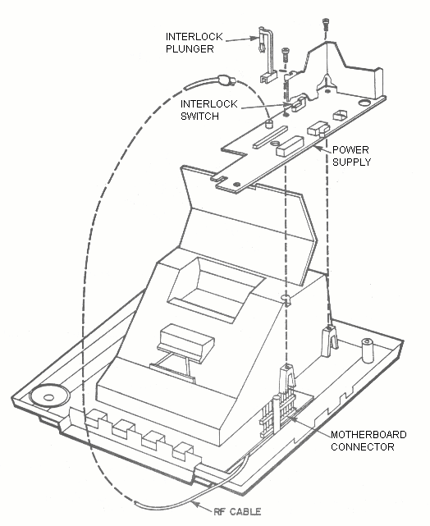

Figure 5-20. 400 Console, Power Supply Removal

5-36 System Service Manual
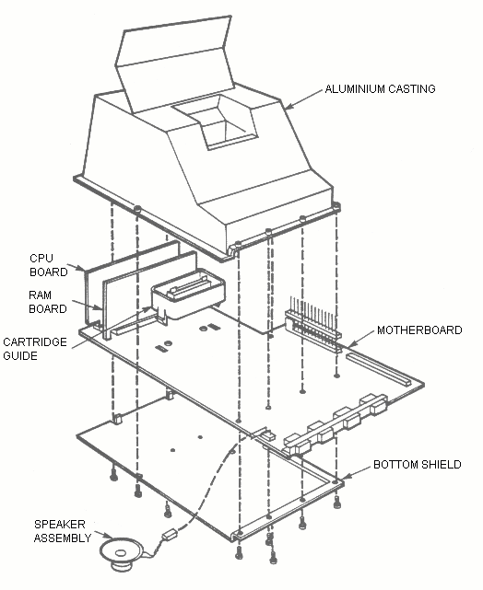

Figure 5-23. 800 Console,, Bottom Cover Removal

ATARI Personal Computers 5-37
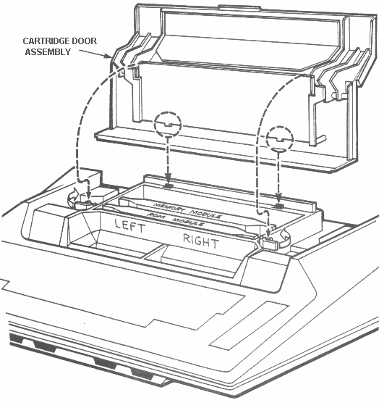

Figure 5-22. 800 Console, Cartrige Door Assemly Removal

5-38 System Service Manual
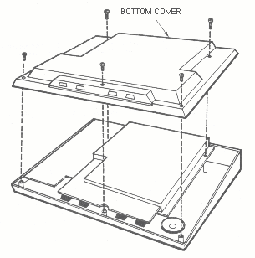
Figure 5-23. 800 Console, Bottom Cover removal

4. Power Supply removal, refer to Figure 5-26
- Unplug RF Cable from Power Supply board
- Unplug Power Supply Harness
- Remove three screws (no. 6 32x5/16) from Power Supply board
- Lift Power Supply board straight up

CAUTION

Be careful not to bend pins of Keyboard Cable

ATARI Personal Computers 5-39
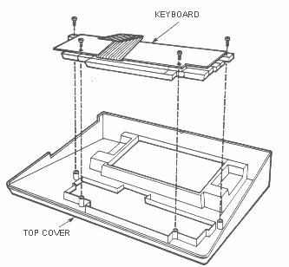
Figure 5-24. 800 Console, Keyboard Removal

5. Access to CPU Printed Circuit Board, refer to Figure 5-27

- Set Module Assembly on its back

- Remove nine screws (no. 6 32x5/8) from Lower Shield

- Lift Motherboard and Lower Shield out of aluminum casting

- Remove CPU printed circuit board

6. Access to Motherboard, refer to Figure 5-28

- Carefully slide screwdriver underneatn Motherboard next to nylon clip. Gently raise handle of screwdriver, prying off. Repeat operation for other three nylon clips.

- Lift Motherboard off Lower Shield

CAUTION

Be careful not to bend any of the pins on the Motherboard Connector

5-40 System Service Manual
- Remove the plastic Cartridge Guide by unhooking the four latches from bottom side of Motherboard.
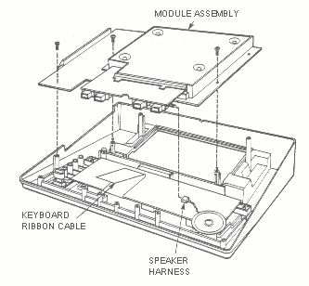
Figure 5-25. 800 Console, Module Assembly Removal

5.7 ASSEMBLY, 400 COMPUTER CONSOLE

The following paragraphs outline the steps required to re-assemble the 400 Computer Console and its related printed Circuit boards.

1. Module Assembly re-assembly, refer to Figure 5-21

- Snap Cartridge Guide into Motherboard (only goes one way)

- Insert RAM Memory bQard and CPU printed circuit board into Motherboard with compQnent side of PCB to the rear. Before re-assembling PCBs be sure that they have been cleaned and lubricatedr refer to paragraph 5.2.1.

CAUTION

Do not allow tip of screwdriver to damage traces

ATARI Personal Computers 5-41
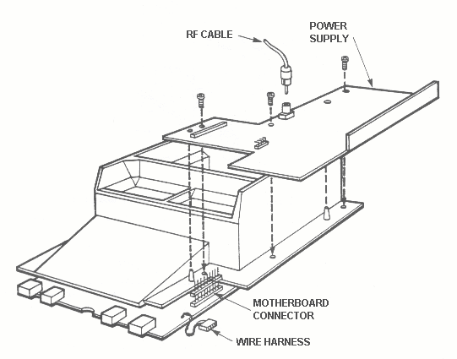

Figure 5-26. 800 Console, Power Supply Removal

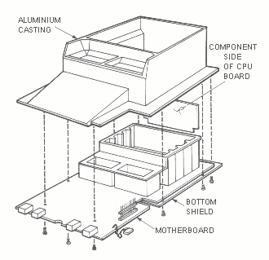
Figure 5-27. 800 Console, CPU Printed Circuit Board Removal
5-42 System Service Manual
- Set Aluminum Casting on its back, invert Motherboard and gently lower into Casting.

NOTE
CPU PCB must fit into guides in the Aluminum Casting

- Install Lower Shield with eight screws (no. 6 32x3/8)

- Install Module Assembly in Bottom Cover

2. Keyboard Installation, refer to Figure 5-19

- Plug Speaker cable into Motherboard (no polarity) and set Speaker in Bottom Cover

- Plug Keyboard ribbon cable into connector on Motherboard

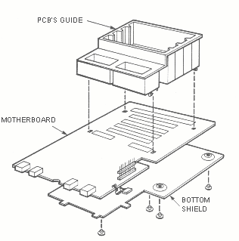
- Gently lower Keyboard over the Power-ON LED and guide posts on Aluminium Casting

Figure 5-28. 800 Console, Motherboard Removal

ATARI Personal Computers 5-43
3. Power Supply installation, refer to Figure 5-20
- Align Power Supply over Motherboard connector pins and Bottom Cover guide posts and gently press down.
- Install Interlock Switch Plunger into Aluminum Casting. Make sure the lower end of the Plunger is positioned over the Interlock switch and the Plunger shaft rides in its' notch in the Power Supply Heat Sink.
- Install two Power Supply mounting screws (no. 6 32x3/8)
CAUTION

Ensure that the RF Cable is not trapped under the Module Assembly

- Route the RF Cable through its' slot in the Power Supply board and plug into Power Supply jack.

Install single Keyboard mounting screw (n o. 6 32x1/4)

4. Top Cover installation, refer to Figures 5-17 and 5-18.

- Open Cartridge Door

- Slide Top Cover down over the open Cartridge Door and Power-On LED.

- Guide the Top Cover locator pins into the Keyboard holes and snap the Top Cover hook under the Keyboard.

- Close the Cartridge Door and set system on its' back

- Align Top and Bottom Covers and install four screws (no. 6 20x1/2) into Bottom Cover.

5.8 ASSEMBLY, 800 COMPUTER CONSOLE

The following paragraphs detail the procedures required to re-assemble the 800 Computer Console and its' associated printed circuit boards.
- Keyboard installat.ion~ refer to Figure 5-24

- Lay Top Cover on its' back with Keyboard in Top Cover o Install four mounting sCrews (no. 6 32x5/8)

5-44 System Service Manual
NOTE

Check spacebar and keys to make sure they are not binding before proceeding to next step
2. Motherboard installation, refer to Figure 5-28

- Snap plastic Cartridge Guide into top side of Motherboard

- With Motherboard right side up, snap onto four nylon clips on Lower Shield. Make sure all four clips are firmly seated.

3. CPU Printed Circuit board installationr refer to Figure 5-27

- Plug in CPU printed circuit board. Make sure component side of board faces away from plastic Cartridge Guide and is firmly seated.

- Set Aluminum Casting on its' back

- Turn Motherboard upside down, set Motherboard and Lower Shield into Aluminum Casting

CAUTION

Ensure CPU printed circuit board sits in its slot in the Aluminium Casting

- Install nine screws (no. 6 32x5/8) in Lower Shield

- Set system on its feet.

4. Power Supply installation, refer to Figure 5-26
- Carefully line up Motherboard pins to Power Supply connector
- Set Power Supply over guide pins on Aluminum Casting and gently press down
- Insert three screws (no. 6 32x5/16) in Power Supply board
- Reconnect Power Supply harness

ATARI Personal Computers 5-45
CAUTION

Plug in Power Supply harness cable with orange or purple wire towards Aluminium Casting

- Plug RF Cable, short tipped end, into Power Supply jack.
- Module Assembly installation into Top Cover, refer to Figure 5-25
- Set Top Cover on its back
- Invert Module Assembly and lower into Top Cover. Rotate Cartridge Door latches to the inside to clear Top Cover.

CAUTION
Make sure RF Cable is not trapped between Power Supply board and Top Cover standoff (upper left screw hole)

- Raise Motherboard one inch out of Top Cover and plug in Keyboard harness

- Install two screws (no. 6 32x3/8) in Aluminium Casting into Top Coverr front holes only

- Set Speaker into recepticle, foam side down

- Connect speaker cable to jack (no polarity)

6. Bottom Cover installation, refer to Figure 5-23
- Align Bottom Cover with four Hand Controller Ports
- Seat Firmly all the way aroundr making sure RF Cable exits through its' hole and is not trappPd between the covers.
- Install five screws (no. 6 32x3/8) in Bottom Cover
- Set sytem on its' feet

5-46 System Service Manual
7. RAM Memory and ROM Memory Modules installation
- Install ROM Memory Module, in slot closest to Keyboard
- Install RAM Memory Modules (maximum of three)
8. Cartridge Door assembly installation, refer to Figure 5-22

- Set Cartridge Door assembly down on Top Cover and slide to the rear to engage tćm slots in the Aluminum Casting

- Lock Cartridge Door assembly down with the two clamps next to the Program Cartridge slots.

ATARI Personal Computers 5-47

CHAPTER 6

SPARE PARTS LIST AND ORDERIL~G/REPORTING INFORMATION

6.1 INTRODUCTION

The following paragraphs will provide a list of the minimum spare parts kits that are to be_ maintained at an authorized Service Center. Also provided will be information for ordering additional parts through the nearest ATARI parts distribution center. Information will also be presented to explain the procedures required to correctly fill out the Part Repair Tag, for both Warranty work and Non-Warranty work.

6.2 SPARE PARTS LIST

The following is a list of the minimum spare parts that are to be maintained at an authorized Service Center:

Description Part No. Quantity

Modules

800 Motherboard CAO14829 1
400 M otherboard CAO14807 1
800 Power Supply CAO14171 2
400 Power Supply CAO14155 2
CPU Printed Circui.t Board CAO14800 2
lOK ROM Printed Circuit Board CAO14090-01 1
16K RAM Printed Circuxt Roard CAO14802 2
8K RAM Pri.nted Circuit 8oard CAO14802 1

Components - Integrated Circuits

6502 MPU CO14377 4
CTIA CO12295 2
ANTIC CO 12296 2
Custom ROM CO 12499 2
Custom ROM CO 12599 2
Custom ROM CO 12399 2
POKEY CO 12294 2
6520 CO 14795 4
16K RAM CO 14331 6
74LS42 CO 14361 4
CD4051 CO14336 6
CD4050 CO 10816 4
74LS10 CO 14339 4
74LS138 CO 14344 4
74LS02 CO 14340 4
7474 CO 14311 4

ATARI Personal Computers 6-1
Description Part No. Quantity

C omponents - Integrated Circuits (Cont.)

74LS244 CO14313 4
74LS158 CO14345 4
74LS00 CO14341 4
74LS09 CO14341 4
Transistor Array CO10174 4
74LS243 CO14347 4
74LS32 CO14362 4

Components - Other

Operators Manual 800 CO14769 2
Operators Manual 400 CO14768 2
Keyboard 800 CAO12952-01 1
Keyboard 400 CAO14031 1
RF Cable CAO14851 5
Speaker Assembly CAO11840 4
Power Adapter CAO14748 2
C rystal 3.579575 CO10177 2
Switch, Interlock CO14387 10
Voitage Regulator (5V) CO14349 5
Voltage Regulator (12V) CO14348 5
Module RF ' B' CAO12174 5
400 Miscellaneous Parts Kit
800 Miscellaneous Parts 1
410 Program Cassette Recorder 2

Diagnostic Test

Stand Alone Test Cartridge TE15644 1
Serial Port Jumper Assembly TE15639 1
Controller Port Jumper Assembly TE15638 1

Supplies

Board Cleaning Brush 1
Aud Brush 1
Lubriplate DS-ES 1
Dust Free Cloth 1
Torque Seal 1

6-2 System Service Manual

INDEX

A
AC Power Adapter, 1-7
Any Video Test, 5-9
Assembly, 400 Computer Console, 5-40
Assembly, 800 Computer Console, 5-44
ATARI LOGO, 3-3
ATARI 400/800 Computer Console Description, 1-1
ATARI 400/800 Computer Consoles Installation, 2-1
ATARI 400/800 Computer Consoles Physical Description, 1-7
ATARI 410 Program Cassette Recorder, 3-7

B
BASIC Program Cartridge, 1-9
BREAK, 3-4

C
CAPS/LOWR, 3-3
CAUTION Statement, 1-6
Changes to this Manual, 1-4
CLR-SET-TAB, 3-4
Colorbar Adjustment, 5-11
Colorbar Test, 5-10
Connecting Television Monitor, 2-4
Connecting the AC Power Adapter, 2-4
Connecting the ATARI 810 and 815 Disk Drive, 2-7
Connecting the ATARI 820 and 822 Printer, 2-7
Connecting the ATARI 825 Printer, 2-10
Connecting the ATARI 830 Acoustic Modemr 2-10
Connecting the ATARI 850 Interface Module, 2-9
Connecting the Program Cassette Recorderl 2-3
Connecting the TV Switch Box, 2-2
Controller Port Jumper, 5-7
CTRL, 3 -4

D
Disassembly, 400 Computer Console, 5-30
Disassembly, 800 Computer Console, 5-33
Disk File Manager, 3-2
Display Option, 5-9

E
ESC, 3-4

ATARI Personal Computers I-1
F
Functional Description, 1-3, 4-1

G
General Information, 1-l, 1-3
Graybar Test, 5-10

H
How to Use This Manual, l-2

I
Inserting Program Cartridges, 2-4
Installation, 1-3
Integrated Circuit Replacement Procedures, 5-24
Introduction, 1-l, 2-1, 3-1, 5-l, 6-1

K
Keyboard and Screen Editor Functions, 3-2
Keyboard Test, 5-6

L
List of Effective Pages, 1-4
Maintenance, 1-3, 5-1
Memo Pad Test, 5-3
Motherboard, 5-28

N
NOTE Statement, 1-6
Notice of Changes Page, 1-4

O
Operation of Hand Controllers, 3-7
Operation of the Program Recorder, 3-7
OPTION, 3-7
Optional Equipment, 1-10

P
Paragraph Headings, 1-2
PCB Contact Cleaning and Lubricationr Peripheral Port Jumper, 5-7
Picture Quality Test, 5-5
Port Test, 5-15
Power Supply Replacement, 5-24
Preventive Maintenance, 5-1
Program Cartridge, 3-1
Program Cartridge System Keys, 3-7
Program Cassette Recorder, 1-9

I-2 System Service Manual
R
RAM Test, 5-13
Reader Comment Form, 1-4
Related Documentation, 1-6
Replace RF Cable, 5-23
RETURN, 3-4

S
Safety, 1-6
Screen Editing Functions, 3-5
SELECT, 3-7
SHIFT, 3-3
Shock Test, 5-5
Spare Parts List, 6-1
Spare Parts List and Ordering/Reporting Information
Special Tools Required, 5-7 Specifications, 1-11
Stand Alone Test (Diagnostic), 5-7
START, 3-7
Static Free Work Station, 5-1
System Check-Out, 5-3
System Operation, 1-3, 3-1
System Power-Up, 3-1
System Power-Up With Disk Drive, 3-2
System Power-Up Without Disk Drive, 3-1
SYSTEM RESET, 3-7

T
Tech Tips, 1-4
Test Equipment, 1-1
Tone Test, 5-16
Transfer a Program to Cassette Tape, 3-8
Transfer a Program from Tape to Computer, 3-9
Troubleshooting – Procedure Number One, 5-20
Troubleshooting – Procedure Number Three, 5-23
Troubleshooting - Procedure Number Two, 5-21
Troublestnuoting Guide, 5-17
TV Switch Box, 1-7

U
Unpacking, 2-1
Using the ATARI 850 Interface Module, 2-8

V
Video Tests, 5-9
Visually Inspecting the Computer Gonsoles, 5-3

ATARI Personal Computers I-3
W
WARNING Statement, 1-6
With Program Cartridge, 3-1
Without Program Cartridge, 3-1

I-4 System Service Manual

